# 



# School of InfoComm Technology

**Intelligent Enterprise Systems**

Year 2 (2022/23), Semester 3

**ASSIGNMENT 2**

**(Individual Assignment)**

**Submission Deadline:**

**10th August 2022 2359hrs**

|  |  |  |
| --- | --- | --- |
| **Student Name** | **:** | Brian Low De Quan |
| **Student Number** | **:** | S10228107D |

**Penalty for late submission:**

10% of the marks will be deducted every calendar day after the deadline.

**NO** submission will be accepted after 17th Aug 2022, 2359 hrs

Contents

School of InfoComm Technology 1

Part 1 2

Part 2 3

Indicator(Numeric Point) 3

Bar Chart 3

Smart Insight 4

Line Chart with Forecast 5

Geo Map 5

CGR Line Bar Chart 6

Table 6

Bubble & Donut Chart 7

Input Control 7

Smart Discovery 8

Story: 9

Reflection: 9

# Part 1

# Part 2

## Indicator(Numeric Point)

The above was created using an Indicator to showcase the Sales for 2020 SAC Retailer Dataset, followed by the Average Sales per Product Category and Average Market Profits. This was implemented with the mindset of wanting to compare with the previous year sales and profits to gain insight of whether we are earning money compared to the previous year. With this indicator, I can now find out my overall sales of the latest years, followed by the average earning for my product based on category and lastly the profits of each individual market that was set up in each region to know the average profits.

## Bar Chart

By creating bar chart shown above, we can accurately see the Sales revenue of each Region and Product Category. With this visual we can spot out the regions that is generating the most sales and regions that have the least sales, and finally come out with solutions to help increase sales for least popular regions. For Product category, I have set a reference line based on the overall sales generated which is divided by the amount of product category to find the average to be used for the reference line as indication. This will help us gauge which product is more popular as compared to the other products and come up with commercial to boost the sales for the particular product.

## Smart Insight

By implementing Smart Insight, users can gain more information about specific products that affects the sales with more in-depth findings to help users formulate future graph to visualise the findings. As shown below, is an example of visuals that is formulated by the SAP analytic clouds to help user gain more useful information about different quarter affecting sales.

## Line Chart with Forecast

The Multi-Line chart was created to view total sales generated overtime together with the quantity that is being sold to find a correlation between them. With this company can find the seasonality of when product is being sold the most such as quarter 4 and come up with counter measure plans to increase sales revenue for earlier quarter such as 1 and 2. By predicting the next quarter sales, I have created a predictive analysis where it read the sales flow for the past 2 years and predicted a low sale for 2021 quarter 1 based on the analysis found for the past 2 years quarter 1 sales.

## Geo Map

This Geo Map was generated to view the sales revenue throughout the globe to find specifically the location that generate the most revenue and by left clicking the country, we can drop down into specific cities of the country to find which city generated the most sales. This helps company to make better decision as to where to implement their business for 2021.

## CGR Line Bar Chart

The chart above shows the Sales revenue generated throughout the 2 years. By using specific analysis techniques such as CGR line, we can find out the overall increment of sales based on percentage value to find out from the start of 2019 to the end of 2020, the percentage of sales growth so company can know the uptrend or downtrend of their business.

## Table

The Table above was created with the reference of modern stock market where user can view the amount of quantity sold in each market, followed by the sales, and profit it earn by selling products. I have also created a number threshold to define the status of each market to show which market is doing well, also market that is not doing well. This Table shows the latest year profit of the market.

## Bubble & Donut Chart

The above bubble chart was created to find out the Sales and Profits of each market gauge by the size of bubble defining the number of products sold in each market throughout the whole dataset. By hovering to specific bubble, we can find the Sales and Profit, inclusive of total quantity of products for each market.

The pie chart showcases the Profit for each product category with Camera being the most profit earned followed by TV and lastly Audio & HiFi. It shows the percentage of profit for user to gauge the popularity of products sold.

## Input Control

The input control above, which was called “slicer” in power bi, was created to filter between the years so that the overall story can be interacted between years. The input control can also be implemented with linked analysis to link specific visuals with the order date input control, so the selected visuals is responsive to the years I have enabled similarly to power bi “edit interaction” tool.

## Smart Discovery

Smart discovery was used by selecting variables that users find hard to understand. It is to help users simulate visuals that can help provide useful insight on unexpected outcomes that we will not expect while creating visuals for SAC Retailer Analysis. Follow by how each data affects the selected variable, whether it highly or lowly influence, the impact of other data affecting the variables. Moving on, smart discovery also help user find out the unexpected value for example the actuals sales and expected sales, with this we can tell whether we have hit our yearly target based on the table created. The data I have selected for analysis were Product Name, Sub-Category, Category, Market, and using smart discovery I was able to formulate visuals I have never thought of while building my story.

## Story:

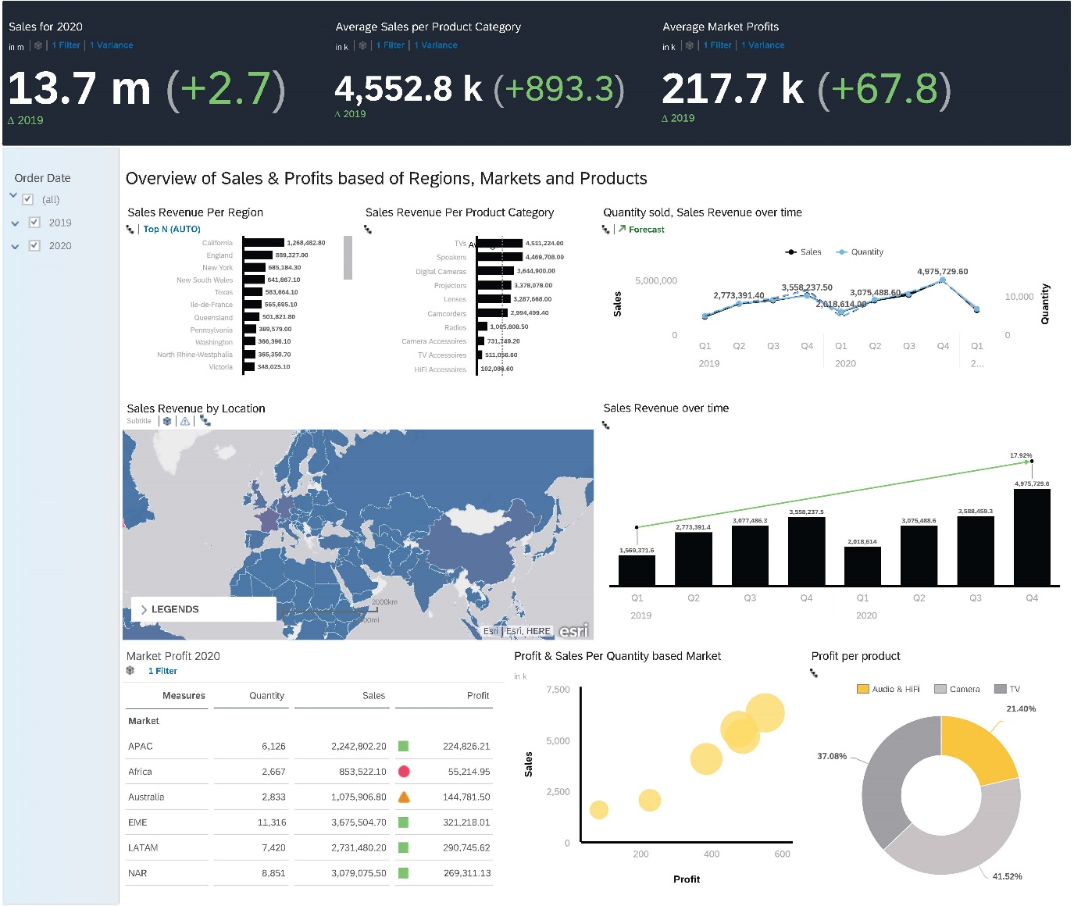

## Reflection:

After spending days learning about SAP Analytics Cloud, I have found the website to have both merits and demerits while using the analytics cloud. First impression for this analytics clouds website is it has a very high security login system behind it, reason being every session will require us to re-login as it does not manually enter the website unless we enable the remember me button. Moving on, the software is very user friendly as it provides a guide through of the overview screen for user to know the basics of using the websites. With 4 simple tasks of viewing a sample story, followed by setting our own story and user profile and allowing us to enter the help centre to know more about the website.

The things I like about the website while creating my story is due to it bottomless grid that can create as much visuals as you like without adding an additional page to contain them as compared to power bi or tableau where they have a fix amount of grid for users to drag their visuals around which can be very compact if user have overwhelming number of visuals. Secondly, analytics clouds have amazing analyse features such as reference line which you can see increment of your statistic performance over the years, forecast which you can view the next quarter statistic through prediction of the dataset throughout the years to spot seasonality. SAP analytic cloud also have built in insights such as smart insight which user can inspect the in-depth analysis of visuals to know more about the story, smart discovery that can help user simulate visuals from data selected by users so users can understand more about the data they are dealing with, which provide user insights of data. Overall, analytics cloud provides a lot of user-friendly interfaces that can provide user insights of data, ideas that could not be thought of before, and a big space for users to include their interactive visuals in one page without any restraints.

The demerit part about using the SAP analytic cloud is because it relies on network connections, it can sometimes be very slow moving and takes some time to make our visuals as compared to software such as power bi and tableau where users does not need to enable network to use their software and create visuals. Some of the functions in SAP analytic cloud was not applicable due to implement constraints as the website is still developing hence some features was not applicable due to bugs which will be fix as shown in diagram below.

This is one of the features I wanted to implement but could not be due to constraints where I wanted to compare my profit under market profit 2020 to the indicator measure average market profit but was not able to implement the percentage value to the way I wanted under the range of threshold. Hence, I could only do the number range way where I must manually enter the numbers I want to set for the threshold. Lastly, the drag and drop of visuals can be improve as user must hold specific spots for the dragging of visuals to work, ultimately slowing down user’s time for creating visuals while trying to change the layout of their story as compared to power bi visuals that is easily movable just by clicking it. Overall, the website is responsive if network is good so user will not experience too much slow down in their work progress, and the analytic cloud is still developing new features so some feature might not be working as intended hence user can probably try different alternative to showcase their intended visuals.

To summarise, I have a great experience learning SAP analytic cloud and would use their SAP product when given the needs to due to it user interactive friendliness and the features that can help visualise diagram and provide useful insights to help data analytics know more about the dataset they are working with. While the drawback may be insignificant, but it can still affects users that forgot to save their work when network down occurred and have to spent more time getting back to their progress they were once at.